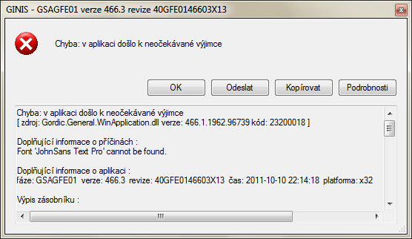
Chyba: v aplikaci došlo k neočekávané výjimce
[ zdroj: Gordic.General.WinApplication.dll verze: 466.1.1962.96739 kód: 23200018 ]

Doplňující informace o příčinách :
Font 'JohnSans Text Pro' cannot be found.

Doplňující informace o aplikaci :
fáze: GSAGFE01 verze: 466.3 revize: 40GFE0146603X13 čas: 2011-10-10 22:14:18 platforma: x32

Výpis zásobníku :

System.ArgumentException:
at System.Drawing.FontFamily.CreateFontFamily(String name, FontCollection fontCollection)
at System.Drawing.FontFamily..ctor(String name)
at Gordic.GFE.Parsers.GFEFontFamily..ctor(String fontname)
at Gordic.GFE.Parsers.GFEFont..ctor(String fontname, Double size, Grr06Metrics smet, FontStyle style, GraphicsUnit un, Byte charset)
at Gordic.GFE.Parsers.GFEFormatStyle..ctor(IGFormatGRRCellStyle style)
at Gordic.GFE.Parsers.GFEFormatContent..ctor(GFEFormatRegion r, IGFormatContent t, IGFormatDevTools dev)
at Gordic.GFE.Parsers.GFEFormatContentText..ctor(GFEFormatRegion reg, IGFormatContentText t, IGFormatDevTools dev)
at Gordic.GFE.Parsers.GFEFormatTag._Create(GFEFormatRegion reg, IGFormatTag t, IGFormatDevTools dev)
at Gordic.GFE.Parsers.GFEFormatTag.Create(GFEFormatRegion reg, IGFormatTag t, IGFormatDevTools dev)
at Gordic.GFE.Parsers.GFEFormatTag..ctor(GFEFormatRegion r, IGFormatTag t, IGFormatDevTools dev)
at Gordic.GFE.Parsers.GFEFormatContent..ctor(GFEFormatRegion r, IGFormatContent t, IGFormatDevTools dev)
at Gordic.GFE.Parsers.GFEFormatGRRCell..ctor(GFEFormatRegion reg, IGFormatGRRCell cell, IGFormatDevTools dev)
at Gordic.GFE.Parsers.GFEFormatTag._Create(GFEFormatRegion reg, IGFormatTag t, IGFormatDevTools dev)
at Gordic.GFE.Parsers.GFEFormatTag.Create(GFEFormatRegion reg, IGFormatTag t, IGFormatDevTools dev)
at Gordic.GFE.Parsers.GFEFormatTag..ctor(GFEFormatRegion r, IGFormatTag t, IGFormatDevTools dev)
at Gordic.GFE.Parsers.GFEFormatContent..ctor(GFEFormatRegion r, IGFormatContent t, IGFormatDevTools dev)
at Gordic.GFE.Parsers.GFEFormatGRRLine..ctor(GFEFormatRegion reg, IGFormatGRRLine line, IGFormatDevTools dev)
at Gordic.GFE.Parsers.GFEFormatTag._Create(GFEFormatRegion reg, IGFormatTag t, IGFormatDevTools dev)
at Gordic.GFE.Parsers.GFEFormatTag.Create(GFEFormatRegion reg, IGFormatTag t, IGFormatDevTools dev)
at Gordic.GFE.Parsers.GFEFormatRegion..ctor(GFEFormat format, GFEFormatRegion p, IGFormatRegion r, IGFormatDevTools dev)
at Gordic.GFE.Parsers.GFEFormatTag._Create(GFEFormatRegion reg, IGFormatTag t, IGFormatDevTools dev)
at Gordic.GFE.Parsers.GFEFormatTag.Create(GFEFormatRegion reg, IGFormatTag t, IGFormatDevTools dev)
at Gordic.GFE.Parsers.GFEFormatRegion..ctor(GFEFormat format, GFEFormatRegion p, IGFormatRegion r, IGFormatDevTools dev)
at Gordic.GFE.Parsers.GFEFormatTag._Create(GFEFormatRegion reg, IGFormatTag t, IGFormatDevTools dev)
at Gordic.GFE.Parsers.GFEFormatTag.Create(GFEFormatRegion reg, IGFormatTag t, IGFormatDevTools dev)
at Gordic.GFE.Parsers.GFEFormatRegion..ctor(GFEFormat format, GFEFormatRegion p, IGFormatRegion r, IGFormatDevTools dev)
at Gordic.GFE.Parsers.GFEFormat..ctor(IGFormat fmt, GFETempDir temp)
at Gordic.GFE.Parsers.GFEFormat.Load(Object ret, GFETempDir temp)
at Gordic.GFE.Parsers.GFEFormat.LoadFromFile(String filename, GFETempDir temp)
at Gordic.GFE.Parsers.GFEFormat.LoadFromFile(String filename)
at Gordic.GFE.WinClient.GDocTab.LoadFormationFile(String p_fileName, Exception& p_ex)

